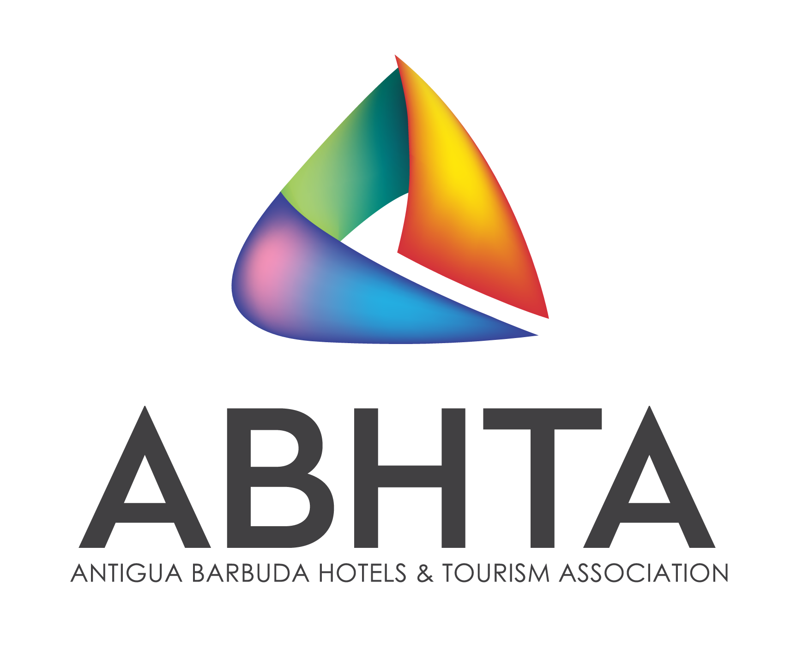

Antigua & Barbuda Hotels
and Tourism Association

Scholarships

Resort Management, Hospitality Management or Tourism Management

Antigua Barbuda Hospitality Training Institute

All applicants must submit the following:

- Completed application form below
- A 1,000-word essay, “What Tourism Means to Me”
- 2 passport sized photos
- Bio Introduction & Resume
- Proof of Antigua & Barbuda Citizenship
- Proof of 5 CXC certification passes to include English and Mathematics

Please indicate preferred course: Resort Management Hospitality Management Tourism Management

Applicant Information
Full Name: |  |  |  | Date:
 | Last | First | M.I.

Address:

Phone: |  | Email

Gender: | M | F | Date of Birth: (day/month/year): / / Age:

Education
High School: |  | Address:

From: |  | To: |  | Did you graduate? | YES | NO | Diploma:

College: |  | Address:

From: |  | To: |  | Did you graduate? | YES | NO | Degree:

Other: |  | Address:

From: |  | To: |  | Did you graduate? | YES | NO | Degree:

Community Service or Leadership Experience

Outline in what ways you have been involved in serving your community or excelled in a leadership role:

Terms and Conditions

- Scholarships are for Resort Management or Hospitality Management, 2 Year Associate Degree Programmes ONLY.
- Scholarships are for students desirous of attending or are currently enrolled at the Antigua Barbuda Hospitality Training Institute (ABHTI).
- For students currently enrolled at the ABHTI applying for a scholarship, must have a 3.25 GPA average.
- The scholarship covers tuition fees ONLY

Disclaimer and Signature
I certify that my answers are true and complete to the best of my knowledge.
I understand that false or misleading information in my application or interview may result in the scholarship being withdrawn.
Signature: |  | Date:

Completed applications must be submitted to the address below before or on the deadline date of: Aug, 20, 2021

Antigua Hotels & Tourist Association
Island House
Newgate Street
St. John’s
Antigua
Tel: 462-0374/4928
Email: anthea@antiguahotels.org

